**Problem-01:**

Given a circle C with radius 10 and center coordinates (1, 4). Apply the translation with distance 5 towards X axis and 1 towards Y axis. Obtain the new coordinates of C without changing its radius.

**Solution-**

Given-

* Old center coordinates of C = (Xold, Yold) = (1, 4)
* Translation vector = (Tx, Ty) = (5, 1)

Let the new center coordinates of C = (Xnew, Ynew).

Applying the translation equations, we have-

* Xnew = Xold + Tx = 1 + 5 = 6
* Ynew = Yold + Ty = 4 + 1 = 5

Thus, New center coordinates of C = (6, 5).

**Alternatively,**

In matrix form, the new center coordinates of C after translation may be obtained as-

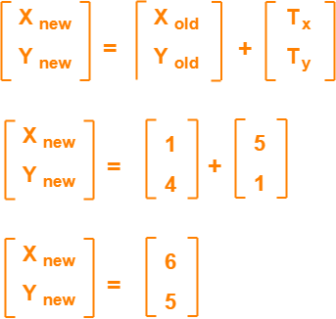

Thus, New center coordinates of C = (6, 5).

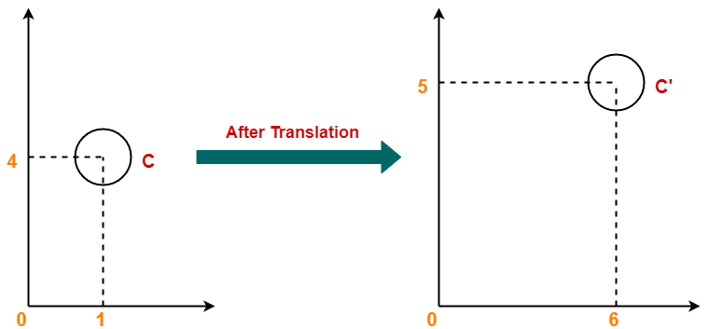

## ****Problem-02:****

Given a square with coordinate points A(0, 3), B(3, 3), C(3, 0), D(0, 0). Apply the translation with distance 1 towards X axis and 1 towards Y axis. Obtain the new coordinates of the square.

## ****Solution-****

Given-

* Old coordinates of the square = A (0, 3), B(3, 3), C(3, 0), D(0, 0)
* Translation vector = (Tx, Ty) = (1, 1)

### ****For Coordinates A(0, 3)****

Let the new coordinates of corner A = (Xnew, Ynew).

Applying the translation equations, we have-

* Xnew = Xold + Tx = 0 + 1 = 1
* Ynew = Yold + Ty = 3 + 1 = 4

Thus, New coordinates of corner A = (1, 4).

### ****For Coordinates B(3, 3)****

Let the new coordinates of corner B = (Xnew, Ynew).

Applying the translation equations, we have-

* Xnew = Xold + Tx = 3 + 1 = 4
* Ynew = Yold + Ty = 3 + 1 = 4

Thus, New coordinates of corner B = (4, 4).

### ****For Coordinates C(3, 0)****

Let the new coordinates of corner C = (Xnew, Ynew).

Applying the translation equations, we have-

* Xnew = Xold + Tx = 3 + 1 = 4
* Ynew = Yold + Ty = 0 + 1 = 1

Thus, New coordinates of corner C = (4, 1).

### ****For Coordinates D(0, 0)****

Let the new coordinates of corner D = (Xnew, Ynew).

Applying the translation equations, we have-

* Xnew = Xold + Tx = 0 + 1 = 1
* Ynew = Yold + Ty = 0 + 1 = 1

Thus, New coordinates of corner D = (1, 1).

Thus, New coordinates of the square = A (1, 4), B(4, 4), C(4, 1), D(1, 1).

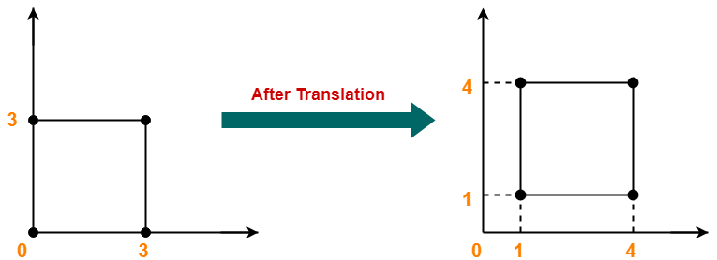

## ****Problem-01:****

Given a line segment with starting point as (0, 0) and ending point as (4, 4). Apply 30 degree rotation anticlockwise direction on the line segment and find out the new coordinates of the line.

**Solution-**

We rotate a straight line by its end points with the same angle. Then, we re-draw a line between the new end points.

Given-

* Old ending coordinates of the line = (Xold, Yold) = (4, 4)
* Rotation angle = θ = 30º

Let new ending coordinates of the line after rotation = (Xnew, Ynew).

Applying the rotation equations, we have-

Xnew

= Xold x cosθ – Yold x sinθ

= 4 x cos30º – 4 x sin30º

= 4 x (√3 / 2) – 4 x (1 / 2)

= 2√3 – 2

= 2(√3 – 1)

= 2(1.73 – 1)

= 1.46

Ynew

= Xold x sinθ + Yold x cosθ

= 4 x sin30º + 4 x cos30º

= 4 x (1 / 2) + 4 x (√3 / 2)

= 2 + 2√3

= 2(1 + √3)

= 2(1 + 1.73)

= 5.46

Thus, New ending coordinates of the line after rotation = (1.46, 5.46).

**Alternatively,**

In matrix form, the new ending coordinates of the line after rotation may be obtained as-

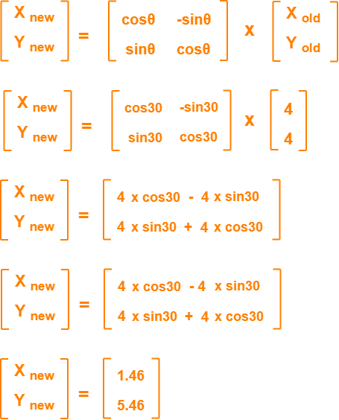

Thus, New ending coordinates of the line after rotation = (1.46, 5.46).

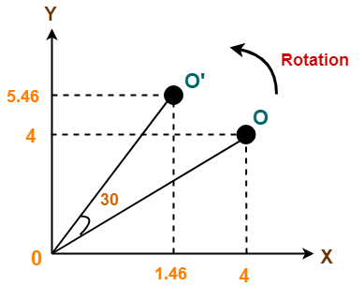

## ****Problem-02:****

Given a triangle with corner coordinates (0, 0), (1, 0) and (1, 1). Rotate the triangle by 90 degree anticlockwise direction and find out the new coordinates.

## ****Solution-****

We rotate a polygon by rotating each vertex of it with the same rotation angle.

Given-

* Old corner coordinates of the triangle = A (0, 0), B(1, 0), C(1, 1)
* Rotation angle = θ = 90º

### ****For Coordinates A(0, 0)****

Let the new coordinates of corner A after rotation = (Xnew, Ynew).

Applying the rotation equations, we have-

Xnew

= Xold x cosθ – Yold x sinθ

= 0 x cos90º – 0 x sin90º

= 0

Ynew

= Xold x sinθ + Yold x cosθ

= 0 x sin90º + 0 x cos90º

= 0

Thus, New coordinates of corner A after rotation = (0, 0).

### ****For Coordinates B(1, 0)****

Let the new coordinates of corner B after rotation = (Xnew, Ynew).

Xnew

= Xold x cosθ – Yold x sinθ

= 1 x cos90º – 0 x sin90º

= 0

Ynew

= Xold x sinθ + Yold x cosθ

= 1 x sin90º + 0 x cos90º

= 1 + 0

= 1

Thus, New coordinates of corner B after rotation = (0, 1).

### ****For Coordinates C(1, 1)****

Let the new coordinates of corner C after rotation = (Xnew, Ynew).

Xnew

= Xold x cosθ – Yold x sinθ

= 1 x cos90º – 1 x sin90º

= 0 – 1

= -1

Ynew

= Xold x sinθ + Yold x cosθ

= 1 x sin90º + 1 x cos90º

= 1 + 0

= 1

Thus, New coordinates of corner C after rotation = (-1, 1).

Thus, New coordinates of the triangle after rotation = A (0, 0), B(0, 1), C(-1, 1).

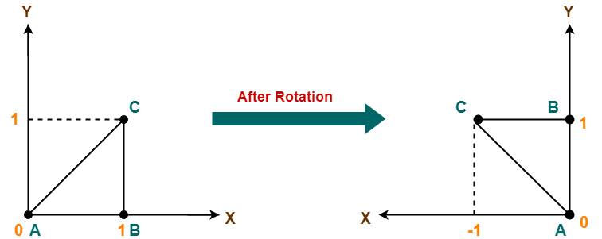

## ****Problem-01:****

Given a square object with coordinate points A(0, 3), B(3, 3), C(3, 0), D(0, 0). Apply the scaling parameter 2 towards X axis and 3 towards Y axis and obtain the new coordinates of the object.

## ****Solution-****

Given-

* Old corner coordinates of the square = A (0, 3), B(3, 3), C(3, 0), D(0, 0)
* Scaling factor along X axis = 2
* Scaling factor along Y axis = 3

### ****For Coordinates A(0, 3)****

Let the new coordinates of corner A after scaling = (Xnew, Ynew).

Applying the scaling equations, we have-

* Xnew = Xold x Sx = 0 x 2 = 0
* Ynew = Yold x Sy = 3 x 3 = 9

Thus, New coordinates of corner A after scaling = (0, 9).

### ****For Coordinates B(3, 3)****

Let the new coordinates of corner B after scaling = (Xnew, Ynew).

Applying the scaling equations, we have-

* Xnew = Xold x Sx = 3 x 2 = 6
* Ynew = Yold x Sy = 3 x 3 = 9

Thus, New coordinates of corner B after scaling = (6, 9).

### ****For Coordinates C(3, 0)****

Let the new coordinates of corner C after scaling = (Xnew, Ynew).

Applying the scaling equations, we have-

* Xnew = Xold x Sx = 3 x 2 = 6
* Ynew = Yold x Sy = 0 x 3 = 0

Thus, New coordinates of corner C after scaling = (6, 0).

### ****For Coordinates D(0, 0)****

Let the new coordinates of corner D after scaling = (Xnew, Ynew).

Applying the scaling equations, we have-

* Xnew = Xold x Sx = 0 x 2 = 0
* Ynew = Yold x Sy = 0 x 3 = 0

Thus, New coordinates of corner D after scaling = (0, 0).

Thus, New coordinates of the square after scaling = A (0, 9), B(6, 9), C(6, 0), D(0, 0).

